PROJECT DOCUMENTATION

SALARY SURVEY 2021 -USING ADVANCED EXCEL & SQL

TITLE | Salary Survey 2021
NAME | Swetha .S
COURSE | DADS - Offline
BATCH | August- 2025

TABLE OF CONTENT

1 | INTRODUCTION  DATA OVERVIEW
2 | OBJECTIVE
3 | DATA CLEANING & PRE-PROCESSING  Handling Missing Value  Standardizing Data Types  Handling Inconsistent Values
4 | INCORPORATED CLEANED DATASET IN MYSQL:  Querying
5 | PIVOT TABLE AND DASHBOARD CREATION
6 | INSIGHTS & RECOMMENDATION
7 | CONCLUSION

INTRODUCTION
DATA OVERVIEW:
The data set consist of attributes like Age range, Industry, Job Title , Clarification of job title, Annual salary, Additional Monetary Compensation ,Currency , Other currency , Income clarification ,Country, State , City ,Professional Experience ,Level of education & Gender

OBJECTIVE:
The objective is to analyse the sales trends across various parameters and provide actionable business insights using Advanced Excel & SQL. To identify high performing industry and low performing industry.

DATA CLEANING & PRE-PROCESSING:
The raw data was cleaned by handling missing values, standardizing data types, handling inconsistent values.
HANDLING MISSING VALUES:
For numerical values the missing values were filled with mean value , whereas in the categorical column the missing values were filled with unknown
STANDARDIZING DATA TYPES:
Ensured all columns have appropriate data types
HANDLING INCONSISTENT VALUES:
Variation in spelling got checked. Different formats of the country got clubbed into one and ensured consistent capitalization for categorical columns.
By following the above method cleaned the data .The cleaned data contains 27774 rows.

CLEANED DATA

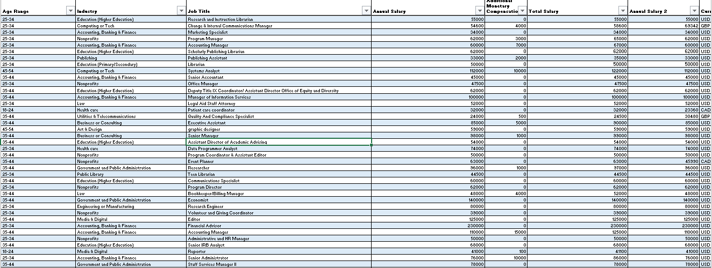

SQL DATABASE CREATION
QUERYING
  - Average salary by industry & gender
  - Total compensation by job title
  - Salary vs. education level
  - Employees by industry & experience
  - Median salary by age & gender
  - Highest salary by country
  - Salary by city & industry
  - Compensation trends by gender
  - Total comp by job & experience
  - Salary by industry, gender & education
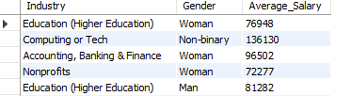

RELATIONSHIP CONNECTIVITY FOR DIFFERENT DATA’s

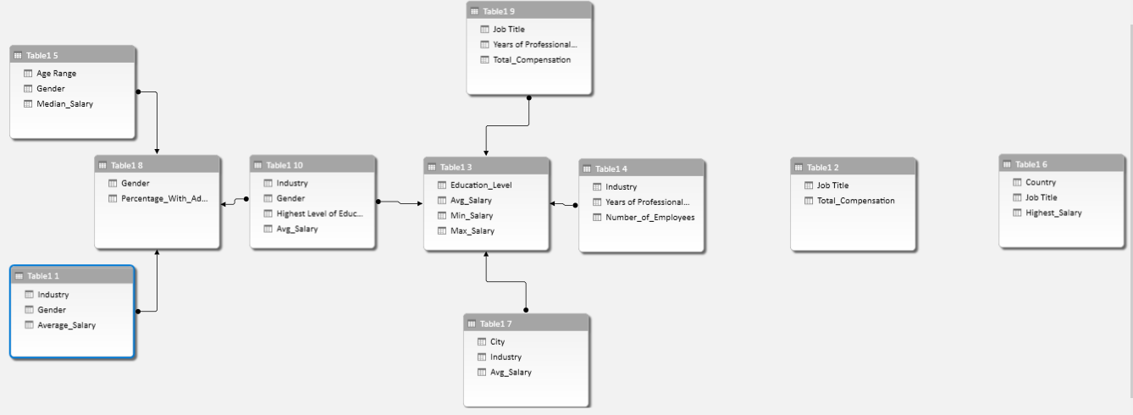

PIVOT TABLE AND DASHBOARD CREATION
- Created Pivot Tables and charts.
- Added Slicers.
- Implemented KPI’s
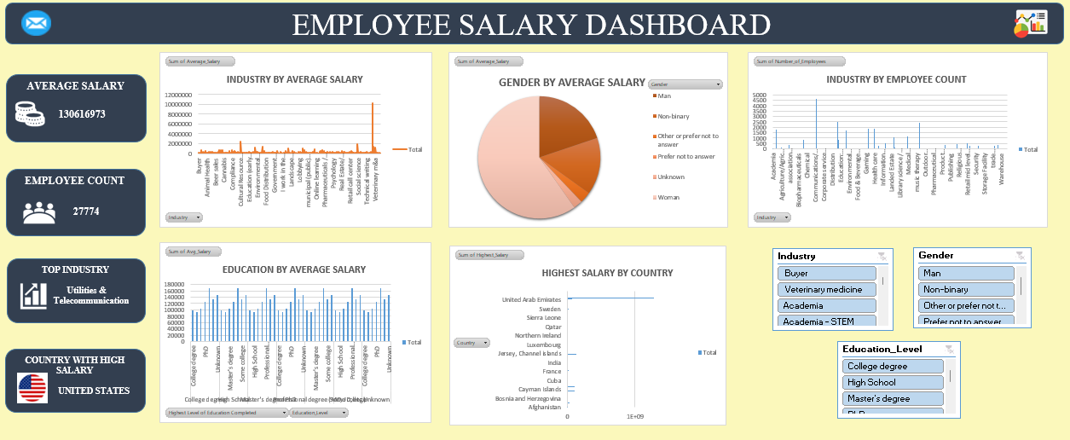
INSIGHTS & RECOMMENDATION:
- Regional operations Manager, Researcher role has more total compensation.
- PhD Qualifications have more salary followed by college degree and Professional degree.

- Computing Technology, Education, Health care have more number of employees.
- In salary trends across gender: non binary has more salary followed by men and then women.
- Highest salary is offered by the country Indonesia and Columbia.
- Even the top-end salary is unimpressive in Lotreland, Myanmar, Bosnia, and Cuba.
- City with highest earning potential is Bogota & Bandung.
- High paying industry are Education, Media & Digital, Utilities & Telecommunication and Accounting & Tech.
- Gender pay gap is around 4% in the given salary dataset
RECOMMENDATION:
- Gender pay gap - It could be managed by providing equal opportunity. Analyse salaries by gender to identify disparities & ensure equal pay for employees with similar experience, skills, and responsibilities.
- Skill incorporation- Despite PhD and Masters degree holds more salary. Inculcating skills and hands on experience in the required field is more essential to yield more results
- Migration rate – If good skills are not appreciated, brain drain could happen. Inorder to avoid migration total compensation, bonus could be given to increase the retention rate.

CONCLUSION
The project helped understand global salary trends using Excel and SQL.
Experience, education, and industry strongly influence salary levels.
Utilities & Telecommunication are the top-paying sectors overall.
PhD professionals earn the highest averages.
United States shows the highest average salary in the dataset.
The analysis highlights gender differences and industry-based variations in pay.

